|  |  |  |  |  |  |
| --- | --- | --- | --- | --- | --- |
| Date | Dec 12, 2022 | | | Tester Name | Syed Shahabuddin |
| Environment | Penfax - Test | | | Login used |  |
| Operating System | Windows | Version: | Update: | | |
| Software Used | Edge | Version: | Update: | | |
| Select Software | Version: | Update: | | |
| Release version | 22.4.1 | | | | |
| Title | E26.10 | | | | |
| Test Type | Regression | | | | |
| Test Scenario | Process a Payment (SMA, LIRA, Lump sum) on the same day as their birthdate & the rollover to another PEPP steps fund. | | | | |
|  |  | | | | |
| Expected Results | The warning “existing instruction will be cancelled” appears & the interfund is cancelled and payment will continue.  Confirm that the payment generated and was paid correctly & that the unit values for the current step are used (not the new one).  The DAI should stay the same (the new step) in case there is a final contribution later on. | | | | |
| Pass/Fail | Pass | | | JIRA# | N/A |

SID: 304098

Searched for member who turns 35 today & found one in PEPP steps:

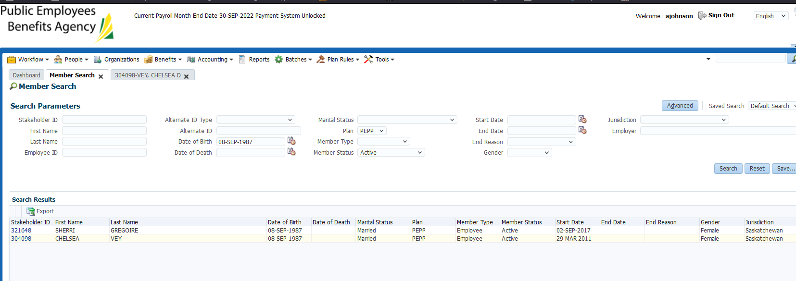

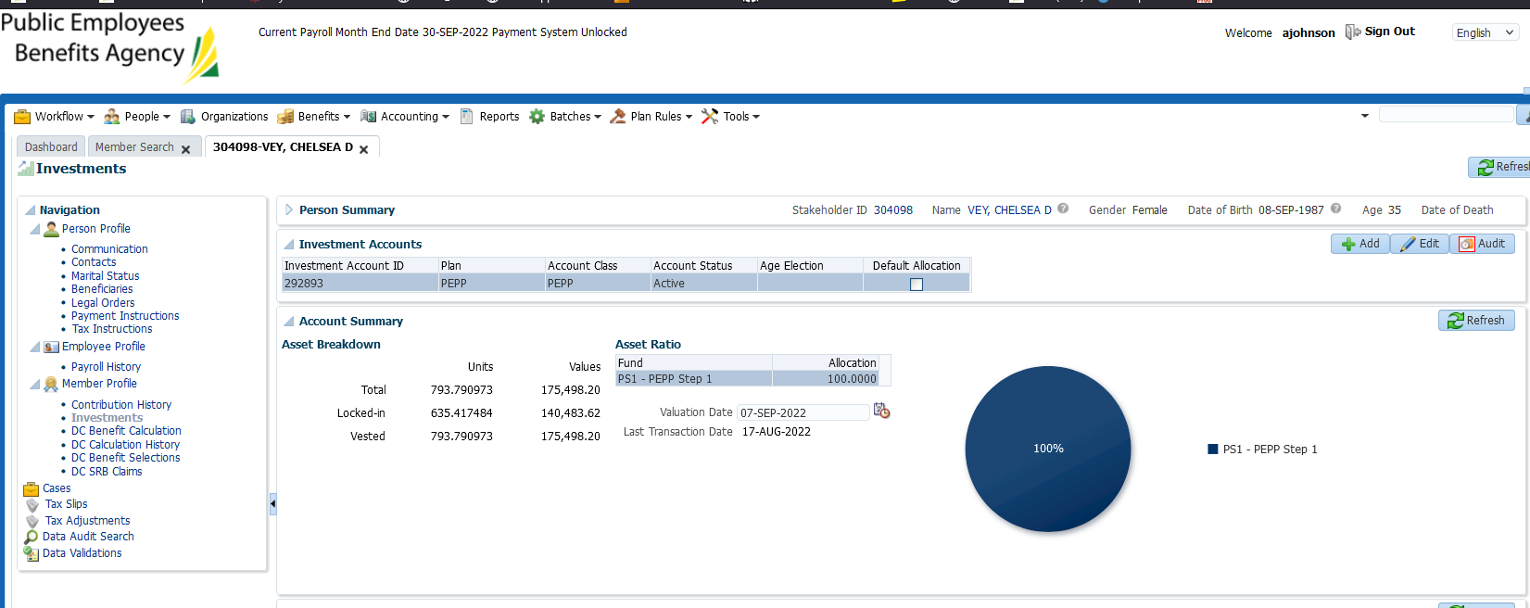

Confirmed the interfund is showing as pending and new DAI was created:

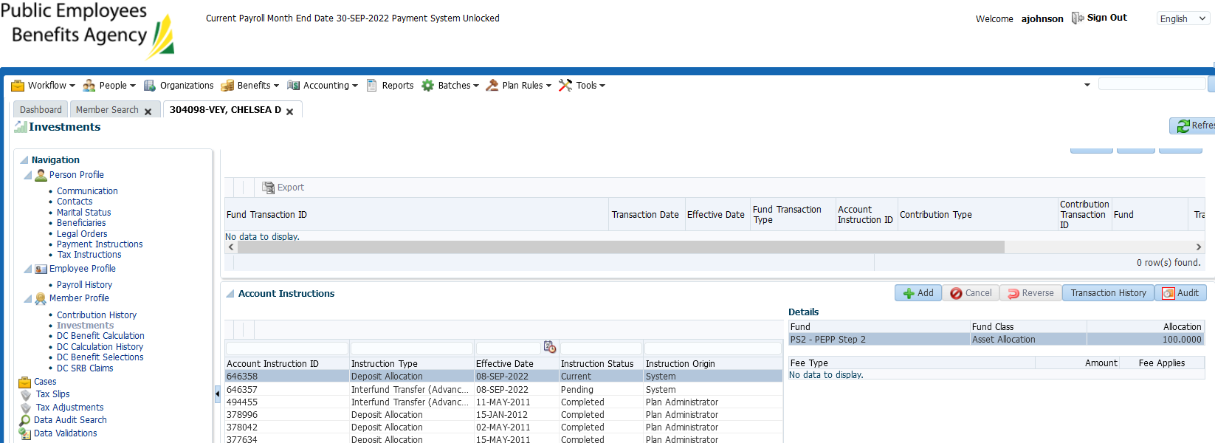

End dated the employment period under employee profile:

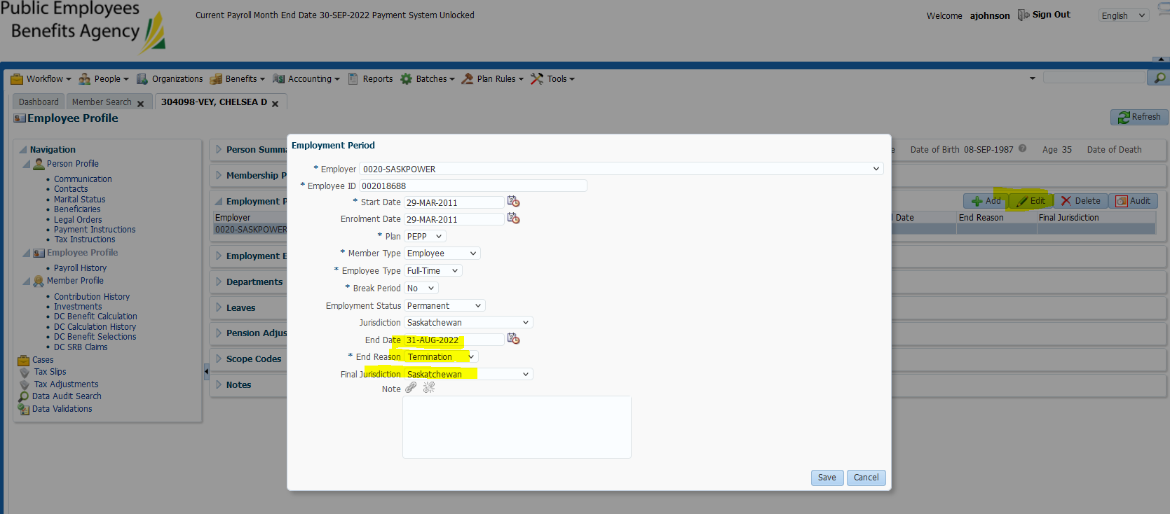

Processed payment:

DC Benefit selection, clicked add, then next

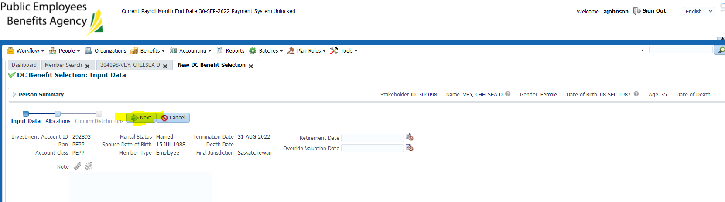

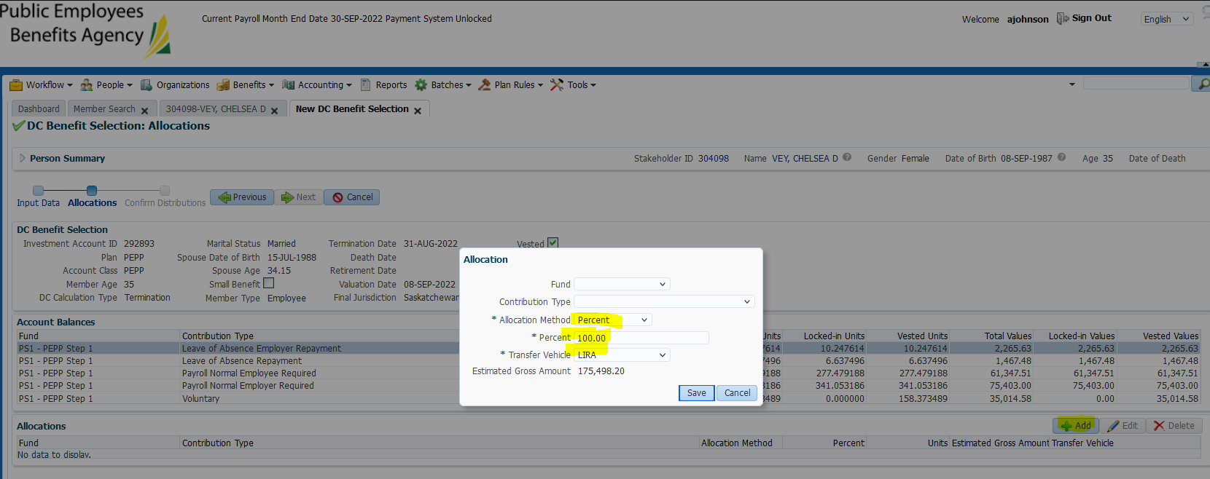

Added payment instruction:

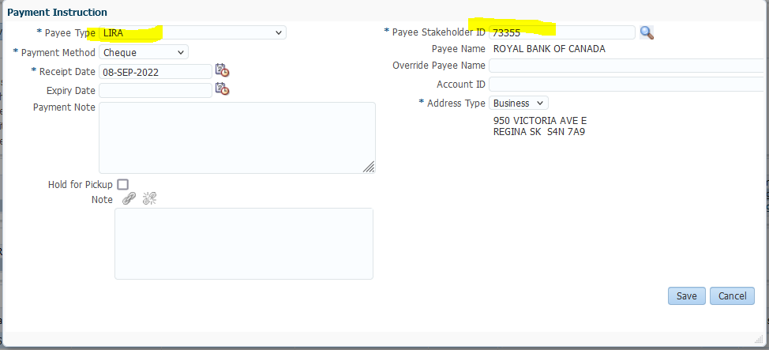

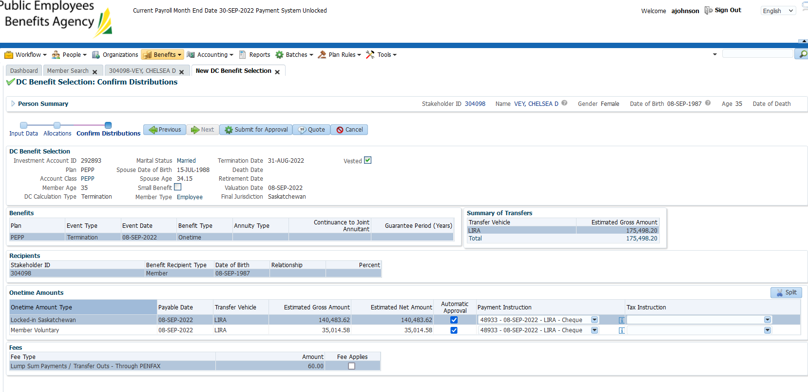

Submitted for approval & approved

Received the following warning:

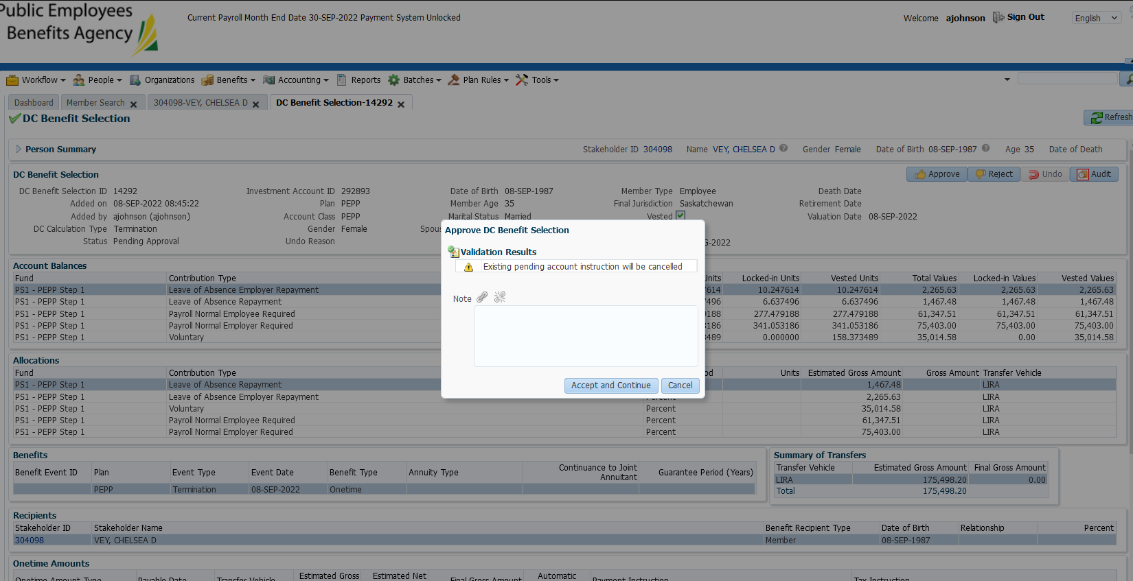

Clicked accept and continue

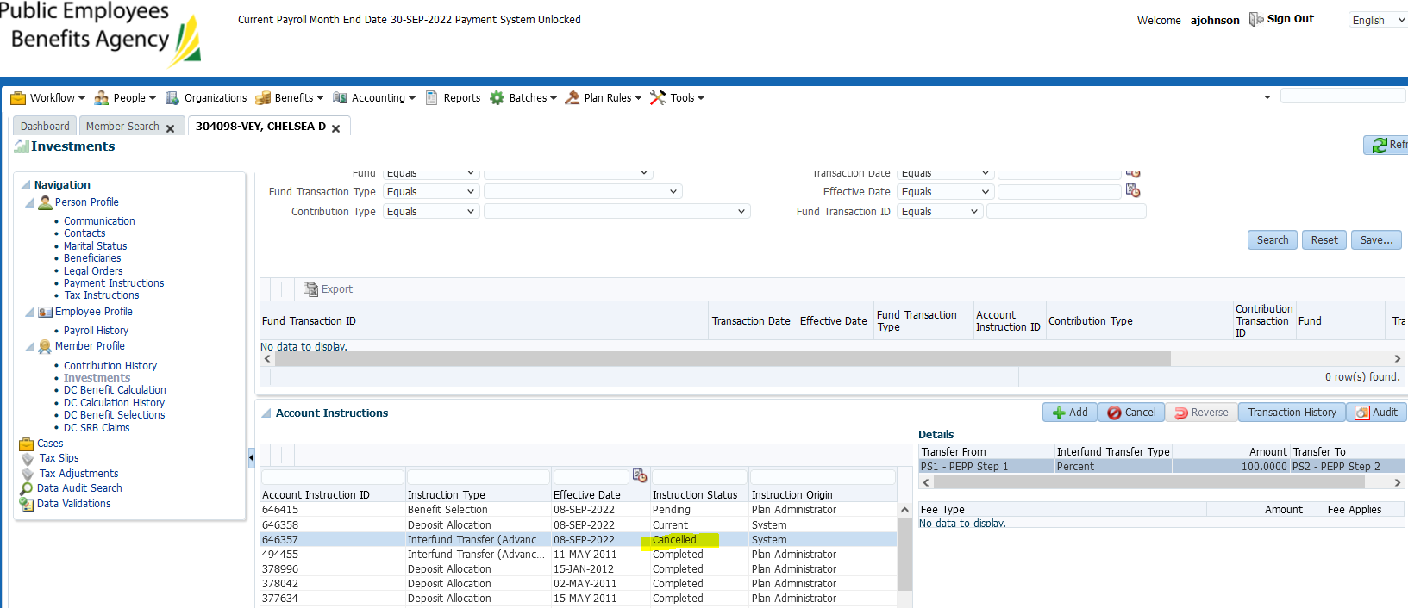

Confirmed interfund is now showing as cancelled

Day 2: checked to ensure the payment has gone through.

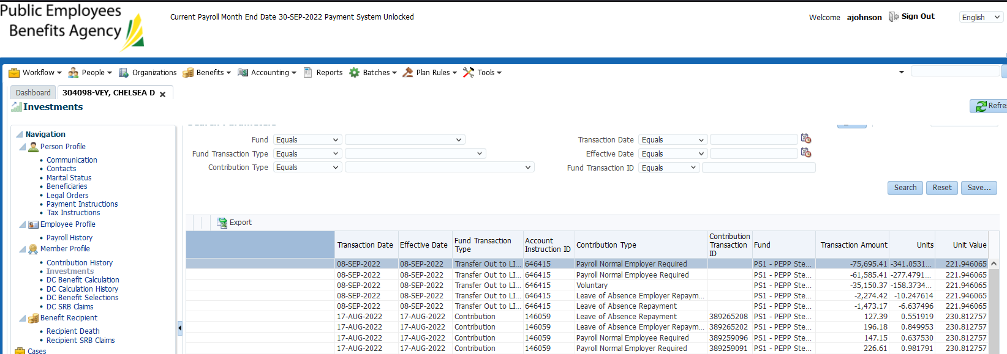

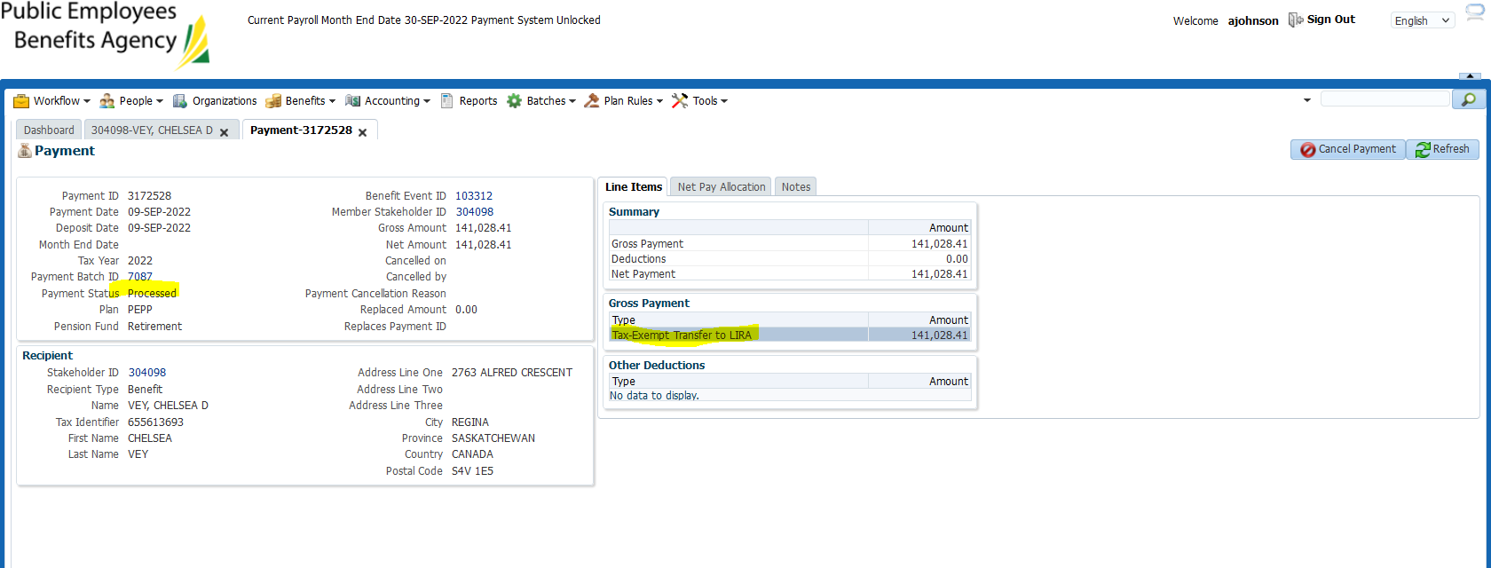

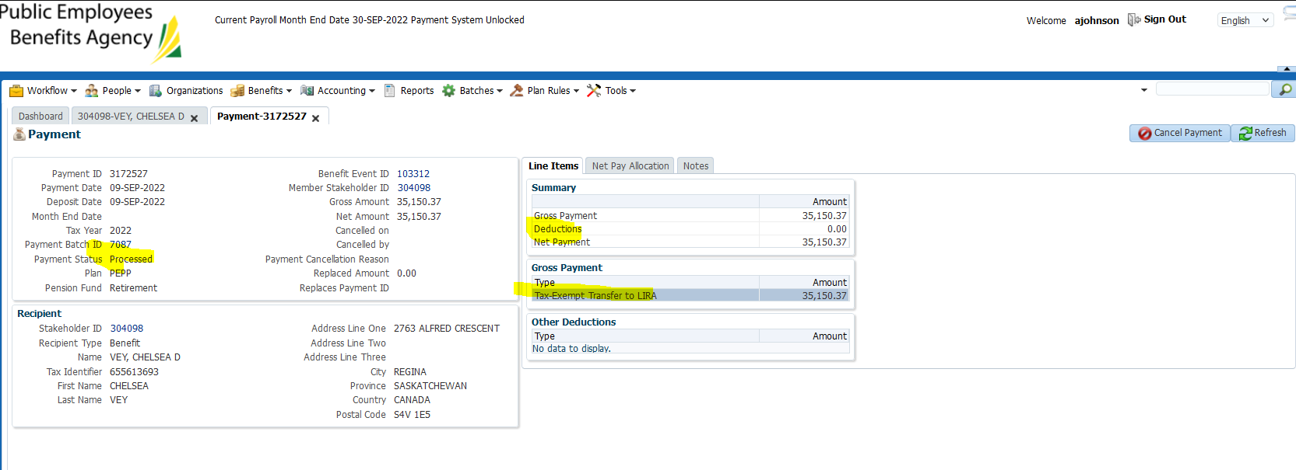

Check back tomorrow for letters – none generated:

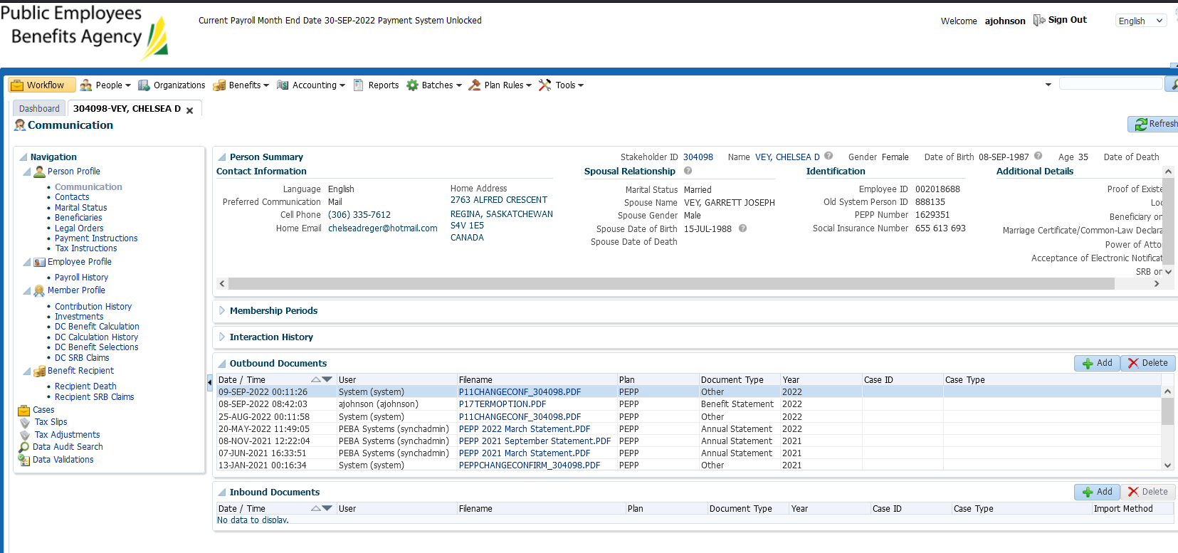

Letters generated (next day):

